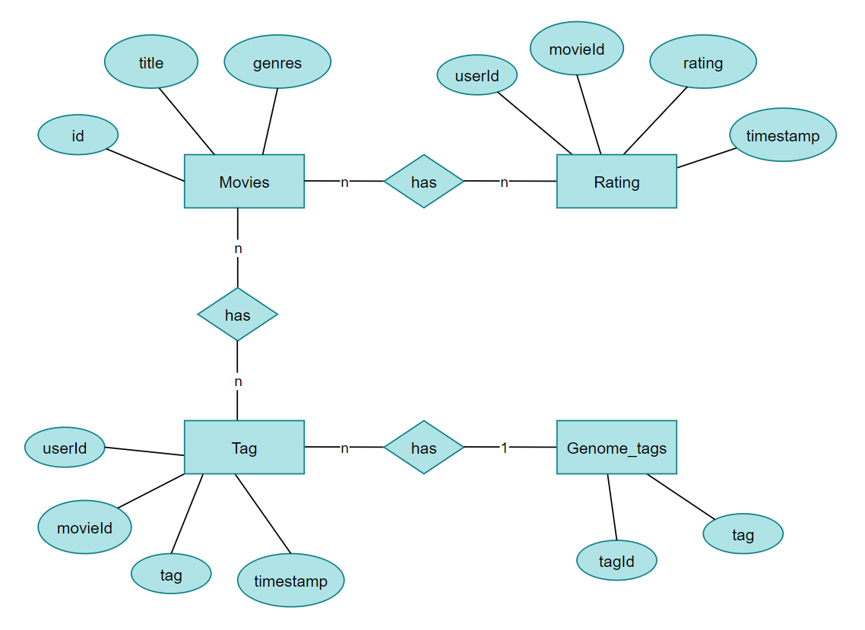
Kleidia???
https://stackoverflow.com/questions/49133853/cassandra-has-two-primary-key-and-use-the-second movie_id

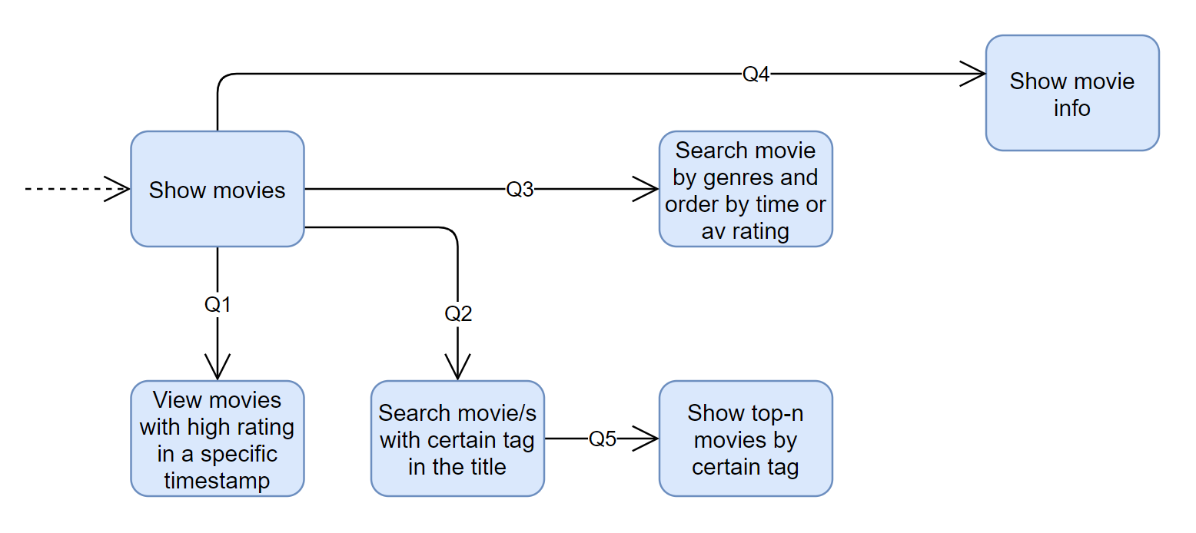
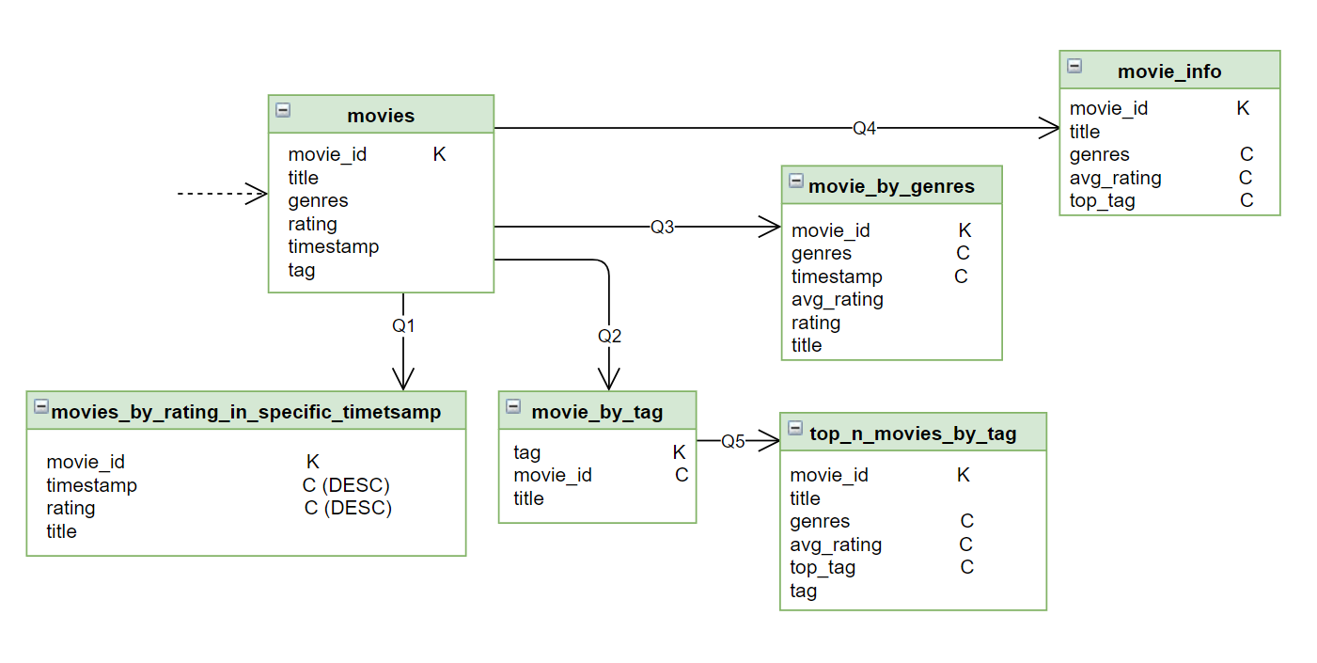
PALIO

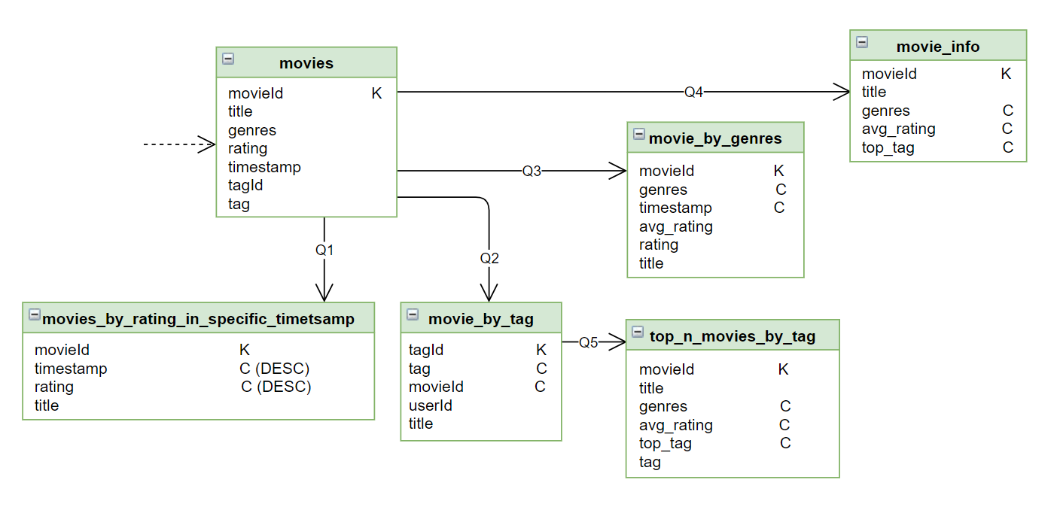
NEO
*timetsamp

DataStax Astra
Όνομα βάσης: projectvaseis
Keyspace: data

Χρησίμα links:
https://docs.datastax.com/en/developer/python-driver/3.25/cqlengine/models/
https://docs.datastax.com/en/developer/python-driver/3.25/getting_started/ (select)
https://pymatix.com/pythoncql/python-cassandra-create-table.php

https://sparkbyexamples.com/pandas/pandas-groupby-sum-examples/ pandas groupby() kai sum()

import csv
import pandas as pd
KEYSPACE = "test_cassandra"
#cluster = Cluster(['127.0.0.1'])
#session = cluster.connect()
csv_filemovie = csv.reader(open('./movie.csv', 'r', encoding="utf8"))
dc = []
datasetmovie=pd.read_csv("movie.csv", sep=',', header=0, on_bad_lines='skip')
print(datasetmovie.head(3))
df2 = datasetmovie[['movieId', 'title']]
#print(df2)
csv_filerating = csv.reader(open('./rating.csv', 'r', encoding="utf8"))
dc3 = []
datasetrating=pd.read_csv("rating.csv",sep=',', header=0, on_bad_lines='skip')
merged_left = pd.merge(left=datasetrating, right=df2, how='left', left_on='movieId', right_on='movieId')
pd.set_option('display.max_rows', None)
pd.set_option('display.max_columns', None)
pd.set_option('display.width', None)
pd.set_option('display.max_colwidth', 1)
print(merged_left.head(5))
csv_filetag = csv.reader(open('./tag.csv', 'r', encoding="utf8"))
dc4 = []
datasettag=pd.read_csv("tag.csv",sep=',', header=0, on_bad_lines='skip')
print(datasettag.head(3))
*****************
παλιο

